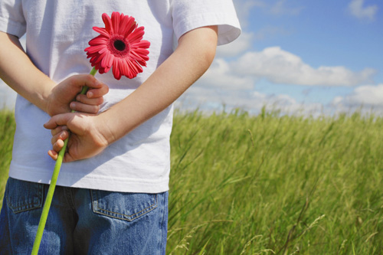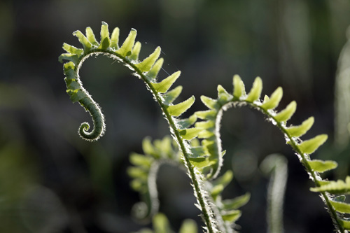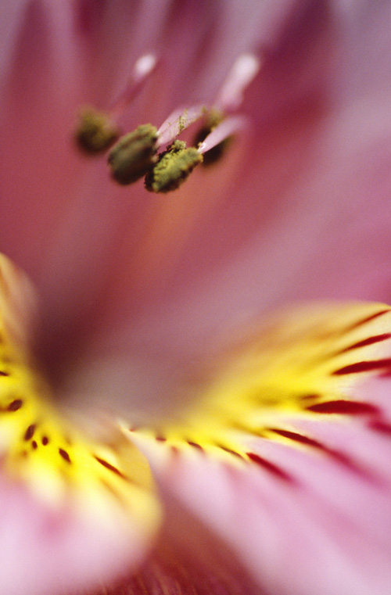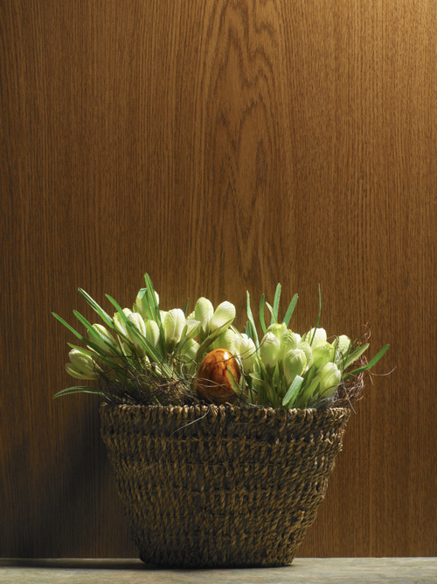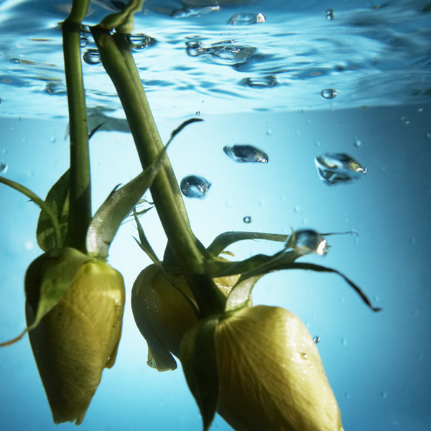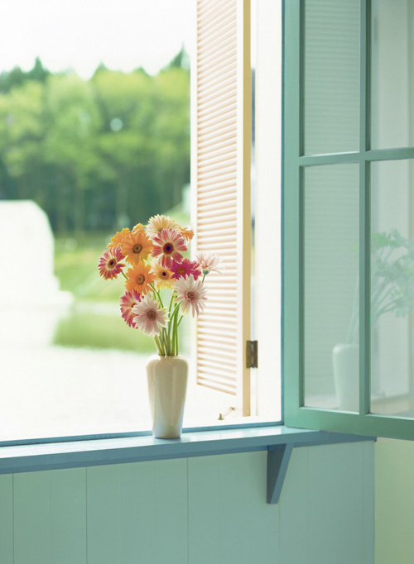

CENTRAL THEME

#### SETTING

#### Detail #1

#### Elaboration (quote, example, info)

#### Detail #2

#### Elaboration (quote, example, info)

**DYNAMIC CHARACTERS**

#### Detail #1

#### Elaboration (quote, example, info)

#### Detail #2

#### Elaboration (quote, example, info)

#### STATIC CHARACTERS

#### Detail #1

#### Elaboration (quote, example, info)

#### Detail #2

#### Elaboration (quote, example, info)

## Theme

Class period

Date

Central Theme Stated

Introduction to your brochure (Summarize each textual evidence)

YOUR GUIDE TO THEME IN *A WRINKLE IN TIME* BY MADELINE L’ENGLE

Name

**Concluding statement on Theme**

Fresh insight or memorable impressions relating to thematic analysis

**Internal Conflicts, External Conflicts, Character vs. char/env**

#### Detail #1-2

#### Elaboration (quote, example, info)

#### Detail #3-4

#### Elaboration (quote, example, info)

# Conflict

### Plot and Character Responses

**Plot**:

Significant Event #1:

* _____Details/Elaborations________
* ______________________________
* ______________________________

Significant Event #2:

* ____ Details/Elaborations _______
* ______________________________
* ______________________________

**Character responses to plot:**

Character #1:

* ___ Details/Elaborations__________
* ______________________________
* ______________________________
* ______________________________

Character #2:

* Details/Elaborations__________
* ______________________________
* ______________________________
* ______________________________

Character #3:

* ___ Details/Elaborations__________
* ______________________________
* ______________________________
* ______________________________